Wykłady dla osób chętnych
semestr letni r. a. 2024/2025
ENGLISH – LANGUAGE PATHS

FIELD OF STUDY: Social Work | - Social Policy in Poland and in Europe (lecture conducted in English)  The lectures provide an overview of social policy, its definitions, paradigms, and connections to other disciplines. They explore the aims, historical development, and models of the welfare state, as well as values, principles, and the role of political ideologies. Participants will examine social policy institutions, approaches to major social issues, and global challenges. Additionally the course covers European social policy and the European social model, offering insights into contemporary welfare systems and solutions.  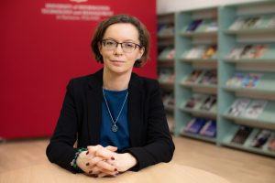  Monika Struck-Peregończyk, Ph.D.  Assistant Professor in the Department of Political Science and Administration. Vice Dean of the College of Media and Social Communication for Social Work. Director of the Academy 50+. PhD in Political Science (University of Warsaw, Faculty of Journalism and Political Science, 2014), MA in English Philology (University of Rzeszow, Faculty of Philology), BA in Political Science (University of Rzeszow, Faculty of Sociology and History).  Her research interests focus on disability studies, contemporary social policy, migration and social mobility.  - Contemporary International Migrations (lecture conducted in English)  The lectures provide an overview of migration, covering its concepts, definitions, and types of migratory movements. It explores global migration trends, the situation of migrants and refugees, and the role of international organizations. Students will learn about the state policies on migration and integration as tools for managing migration flows. Special attention is given to the migration of women and socially excluded groups, as well as the debates surrounding this issue. The students will understand the contemporary migration challenges and policies.  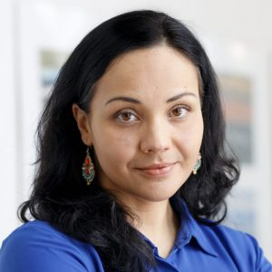  Iwona Leonowicz-Bukała, Ph.D.  Dean of the Faculty of Media and Social Communication, graduated in social sciences in the field of political sciences, cultural studies, journalism and social communication. Her research interests focus on the issues of contemporary migration and media, the presence of ethnic and national problems in the media, with an emphasis on new media and social networks, and the mediatization of migration. Individual tutor in the School of Leaders and Masters of Didactics project. Research tutor for gifted students. An expert in the field of social media and contemporary communication.  - Social Psychology (lecture conducted in English)  The lectures are designed to familiarise students with the key domains of social psychology, focusing on how individuals perceive themselves and others within a social context. Students will learn about the social cognition, beliefs about human nature, and the processes of perception and judgment. Students will examine the origins and functions of the self, the role of self-esteem, and how attitudes are formed, maintained, and changed. The lectures will present detailed information on the social themes such as affiliation, agency, and control, providing insights into the psychological mechanisms shaping social interactions and understanding.  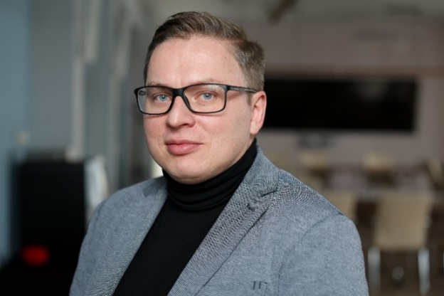  Jan Gosztyła, M.Sc.  Assistant in the Department of Management, Master's degree in psychology, certified addiction therapy specialist, psychotherapist and Gestalt trainer. His research interests focus on stress coping, posttraumatic development, adolescent and adult psychotherapy. To a lesser extent, he is involved in projects in other areas of psychology - environmental psychology and developmental psychology. has many years of experience working as a psychotherapist in addiction treatment centres and mental health clinics. He has many years of experience working as a psychotherapist in addiction treatment centres and mental health clinics.
FIELD OF STUDY: MANAGEMENT | - Corporate finance (lecture conducted in English)  The purpose of the course is to familiarize students with the architecture and operation of the corporate financial management system, to explain the essence and consequences of financial decisions of different nature made in enterprises, as well as to present methods and tools that can be used in evaluating various aspects of the financial activity of the enterprise. During the lecture, such issues as the economics of investments, evaluation of their profitability, sources of capital, optimization of capital structure, as well as issues of enterprise value as a key financial variable will be discussed.  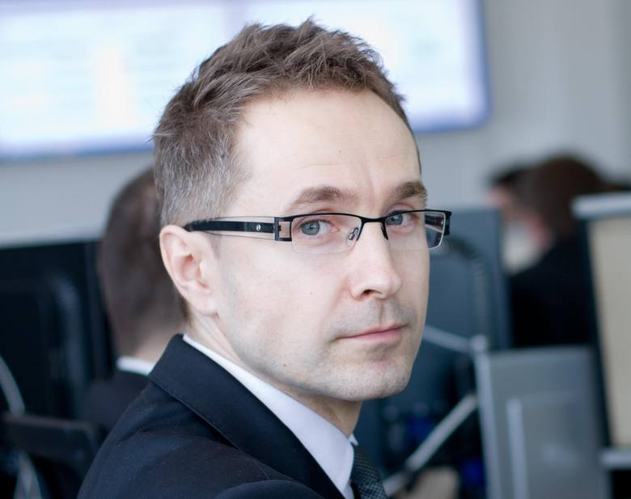  prof. Andrzej Cwynar, Ph.D.  Founder and director of the Institute for Financial Research and Analysis at the University of Information Technology and Management in Rzeszow. Founder and editor-in-chief of the online quarterly "e-Finanse" . Originator and manager of the Financial Laboratory - the first university dealing room in Poland. Author and co-author of more than 100 domestic and foreign publications on enterprise value management, including several books. Independent advisor on the implementation of programs to increase the value of enterprises (including in the chemical, mining and energy industries). Lecturer and trainer conducting classes for, among others, management of PKN Orlen SA, KGHM SA, Zakłady Chemiczne Police SA, Zakłady Azotowe Kędzierzyn SA, Rafineria Nafty Jedlicze SA, Katowicki Holding Węglowy SA and many other companies.  - Startegic management II (lecture conducted in English)  Issues discussed during the course of the course include: Concepts of strategic management, Strategic analysis, The process of formulating corporate strategy, Types of organizational strategies, Implementation of organizational strategies.  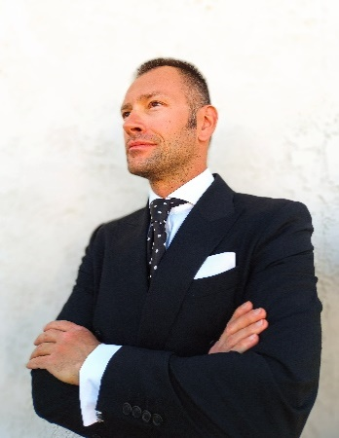  Bartolomeo R. Bialas, MA  For more than 19 years, he has specialized in strategic branding and marketing (brand strategy, competitive marketing strategies, cross-cultural consumer psychology). He has worked for branding, marketing and advertising agencies, MGM Grand, Nevada Governor's Office of Economic Development, The Wynn Resort, New York-New York, Luxor Hotel & Casino, White Square Gallery (Berlin-Germany/Las Vegas-USA), The Rivers Casino (Pittsburgh, PA), RackStar, Plaza Hotel & Casino, ALDEC, Goodwill Industries International and ING Group. Visiting professor at prestigious universities in Latin America and Europe:  - University del Istmo  - Rafael Landivar University  - University del Valle  - Galen University  - University of Palermo  - Francisco Marroquin University  - International Business School / The University of Buckingham  where he teaches original seminars on subjects such as Strategic Brand Management: Psychological and Cultural Perspectives, International Marketing: Cross-Cultural Market, Export Research and Management, Strategic Marketing: Advertising and Integrated Brand Promotion Perspective, Strategic Thinking, and Global Consumer Behavior.  - Fundamentals of macroeconomics (lecture conducted in English)  During the lecture, the audience will learn about the following topics: National income - methods of measurement. The market for goods and services. Global demand and its determinants. Fiscal policy. Money market and monetary policy. Inflation and unemployment. Macroeconomics of an open economy.  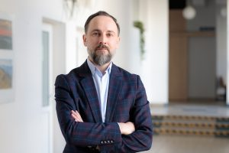  Tomasz Skica, Ph.D., UITM professor  Ass. Professor of economics, author or co-author of about 50 scientific articles on these topics and more than 100 other publications, including analyses, research reports, expert reports and articles in national economic journals. Member of the European Association of Labor Market Economists (EALE). Cooperates with the Bureau of Investment and Economic Cycles in Warsaw. Expert of the IFO institute in Munich in assessing economic trends in Poland. Collaborated regularly with Gazeta Wyborcza and Polish Market magazine.
FIELD OF STUDY:  Applied Information Technology | - Computer systems architecture (lecture conducted in English)  The lecture introduces students to the world of computer hardware. Topics covered include computer logic, arithmetic of computers, classic computer architecture, processors, command lists, assembler language basics, organization of computers on assembler language level, hierarchy of memory in computer systems, interfaces, magistrals, external devices, modern computer architectures, multiprocessor architectures, architectures and features of embedded systems, microcontrollers, microcontrollers programming and reliability of computer systems. In addition, students will learn the latest trends and developments in this area.  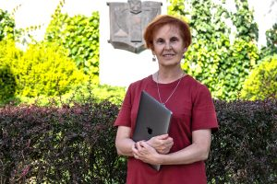  dr Iryna Berezovska  Assistant Professor in the Department of Cognitive Science and Mathematical Modeling  Author of numerous scientific and teaching publications in the fields of e-learning, cyberchondria, nursing informatics, and inclusive education.  From 1991 to 2001, she worked at Lviv Medical University (Ukraine), implementing biomedical databases, and held internships at hospitals in Buffalo, NY (USA). Until 2017, she held the position of assistant professor at the Department of Computer Science at the National Technical University in Ternopil (Ukraine).  In 2000 -2001, she interned at the School of Library and Information Science at the University of San Jose (California, USA) as a Contemporary Issues Fellowship recipient under an academic exchange program sponsored by the US government. As part of the fellowship, she carried out a project entitled Educating Ukrainian Health Professionals to Use Electronic Information Resources.  She is a member of the International Advisory Board of the Hands-on Science Network, which is a European community of educators dedicated to teaching science in schools and universities.  - Algorithms and Data Structures (lecture conducted in English)  This lecture is essential for all who want to efficiently use programming languages in any application area. Moreover, the knowledge gained during this lecture is universal and important for any programming language student will use in the future. Topics covered include:  mathematical foundations of computational complexity of algorithms; introduction to the design of algorithms; construction and features of data structures: arrays, lists, queues, stacks, graphs; methods of designing algorithms: recursion, divide-and-conquer method, dynamic programming, greedy method, return algorithms; use of algorithms to solve problems; estimating the computational complexity (time and memory) algorithms; use of searching and sorting algorithms in data processing problems; using of graph algorithms in transport problems; design problems of concurrent algorithms. A good understanding of these topics guarantees the successful development of your skills as a programmer.  Prof. dr hab. inż. Władysław Homenda, Ph.D.  Professor in the Department of Artificial Intelligence. Employed at the University of Information Technology and Management since 2021. His studies and professional activity were associated with the Warsaw University of Technology: from the Study of Fundamental Problems of Technology to the Faculty of Mathematics and Information Sciences, which was established after the transformation. Simultaneously with his employment at PW, he worked at CICESE, Ensenada, Mexico, co-created the music information processing programs Midiscan and Smart Score published by Musitek, Ojai, California, worked at the University of Bialystok at the Faculty of Mathematics and Informatics and the Faculty of Economics and Information Science in Vilnius. In March 2021, he was hired at UITM. His research and teaching activities are related to the theoretical foundations of computer science and intelligent computing technologies, especially human-friendly methods and knowledge discovery and processing. He collaborates with domestic and foreign institutions. He is a member of the editorial boards of several international scientific journals and a member of the program committees of a number of regular international scientific conferences.  - Databases (lecture conducted in English)  Topics discussed include an introduction to database issues, information models, data modeling, as well as database systems and query languages. You'll also learn what database management systems are, as well as distributed databases and client-server architecture or data warehouses. You'll learn about data manipulation instructions or the secrets of the T-SQL language, as well as how to construct simple and complex queries in SQL.  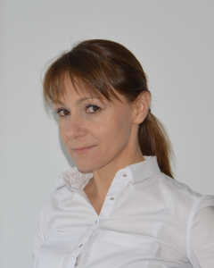  Teresa Mroczek, Ph.D., professor of UITM  Professor in the Department of Artificial Intelligence.  Habilitated doctor of engineering sciences in the discipline of technical informatics and telecommunications (University of Rzeszow, College of Natural Sciences), doctor of technical sciences (Wroclaw University of Technology, Faculty of Computer Science and Management), master of science in computer science (Rzeszow University of Technology, Faculty of Electrical Engineering).  She conducts research in the fields of data mining, knowledge discovery in databases, intelligent exploratory analysis of data, machine learning, expert systems. Her scientific achievements include more than 60 original scientific papers, including: articles in journals, monographs, conference proceedings of national and international scope; scientific reviews of papers published at international conferences; and scientific edits of monographs. Developer of advanced software for data analysis by supervised machine learning methods (BeliefSEEKER, NukleiSEEKER) and solutions for business.
FIELD OF STUDY: nursing | - Public Health (lecture conducted in English)  The lecture aims to provide knowledge on the concepts and tasks of public health. In addition, issues concerning the relationship between contemporary health threats, health policy and the organisation of the health care system in Poland and selected EU countries will be discussed.  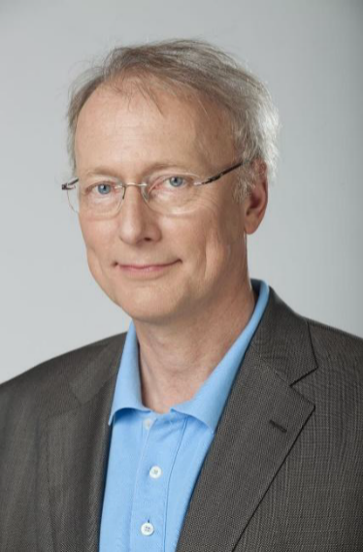  prof. Paweł Januszewicz (PhD, MD)  Professor Paweł Januszewicz, long-standing Director of the Children's Health Centre in Warsaw, National Consultant in Pediatrics, 1994-2001. Member of the Presidium of the Committee for Registration of Medicines (1996-2001). Professor, Head of the Institute of Medicine, Warsaw, (2001-2002). Chairman of the Scientific Council of the POLSAT ZDROWIE I URODA television channel, expert on the POLSAT NEWS television channel. Author of numerous publications in peer-reviewed journals.  - Pharmacology (lecture conducted in English)  The program includes:  Dosages, drug forms, methods of introducing drugs into the body. Disposition of the drug in the body: release, absorption, distribution, metabolism, excretion. Mechanism of action of drugs (synergism, antagonism). Drugs (and their active substances) used in various disease states.  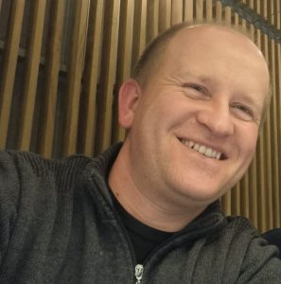  prof. Wojciech Koch, MD, DSc  Professor Wojciech Koch - Lecturer at the Medical College of the University of Information Technology and Management in Rzeszow since 2019. Also Professor at the Medical University of Lublin, Poland.  Professor of medical and health sciences in the discipline of pharmaceutical sciences. Post-doctoral degree in Pharmacy (Medical University of Lublin, Faculty of Pharmacy, 2019), specialist in bromatology, Master of Pharmacy (Medical University of Lublin, Faculty of Pharmacy, 2007).  His scientific interests are: food chemistry, study of non-nutritive substances in rations and food products using chromatographic and spectroscopic methods, evaluation of food products using analytical and chemometric methods.  Since 2021, Head of the Department of Food and Nutrition at the Medical University of Lublin.  - Geriatrics and Geriatric Nursing (lecture conducted in English)  The lecture series on Geriatrics and Geriatric Nursing aims to provide in-depth knowledge of the etiology, symptoms, diagnosis, treatment, and comprehensive care of elderly patients. It will focus on the most prevalent conditions in geriatric medicine, emphasizing interdisciplinary approaches, patient-centered care, and modern advancements in nursing practice for aging populations.  With the global increase in life expectancy, geriatrics has become a critical area of healthcare. The rising number of elderly patients presents new challenges, including multimorbidity, polypharmacy, functional decline, and the need for long-term and palliative care. This lecture series will highlight evidence-based strategies for improving the quality of life, dignity, and safety of geriatric patients while addressing the growing demand for well-trained healthcare professionals in this field. Special attention will be given to chronic disease management, geriatric syndromes, dementia care, and the integration of medical simulation as a key educational tool in preparing nursing students for real-world geriatric care.  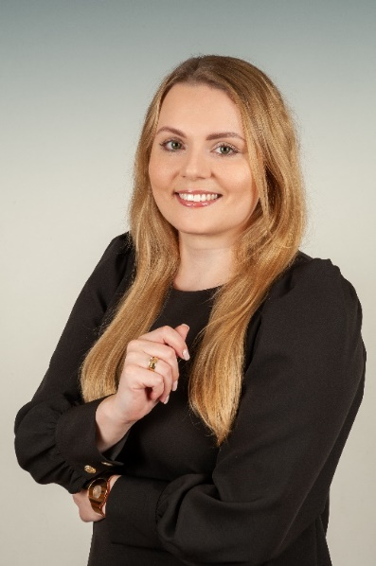  Karolina Kuśnierz, MSN  Karolina Kuśnierz is a lecturer and academic instructor in the Nursing program (English division) at the University of Information Technology and Management in Rzeszów, where she also serves as the Head of the Medical Simulation Center. Her academic and clinical expertise spans geriatrics, long-term care, anesthesiology, intensive care, emergency medicine, and medical simulation, with a strong focus on patient safety and clinical decision-making under critical conditions.  Her professional background includes extensive international experience in critical care, surgery, cardiology, pulmonology, geriatrics, neurology, and internal medicine across leading UK healthcare institutions, including University Hospitals Birmingham NHS Foundation Trust. She has played a key role in resuscitation leadership, student mentoring, and interdisciplinary team training.  Karolina has a strong interest in geriatrics, recognizing the increasing need for specialized geriatric care in the face of an aging population. She is particularly focused on enhancing student preparedness for geriatric patient care, including the use of high-fidelity simulation to improve clinical skills, critical thinking, and decision-making in complex geriatric scenarios.  Currently, she also works as a nurse for TRICARE Overseas, coordinating patient care for the U.S. Department of Defense healthcare program. Her academic and professional pursuits align with the integration of advanced simulation in geriatric education, ensuring that healthcare professionals are well-equipped to meet the evolving challenges of elderly care.

